Manual Pinning Test Plan for runContinuous() Method

IDENTIFIER: COMMAND PROMPT LOOP

TEST CASE: Check that, after clicking ‘Run Continuous’, command prompt prints out that it is running, calculating, and displaying each iteration

PRECONDITIONS: Program is not yet running/user is at command line

INPUT VALUES: java GameOfLife 15

EXECUTION STEPS: Enter java GameOfLife 15 on command line, and then on Game of Life window click ‘Run Continuous’

OUTPUT VALUES:

“Running…

Calculating…

Displaying…”

Repeating infinitely

POSTCONDITIONS: Output values repeat infinitely on command prompt window

IDENTIFIER: FINAL CONTINUOUS CONFIGURATION

TEST CASE: Check that a pattern that is selected on the Game of Life window that will eventually converge does, in fact, converge. This will determine whether or not the ‘run continuous’ button will find a final pattern and will stop flipping tiles correctly.

PRECONDITIONS: Game of Life window is open and awaiting input from user

INPUT VALUES: Click on specific tiles in Game of Life, click Run Continuous

EXECUTION STEPS: Click specific tiles to result in following form:

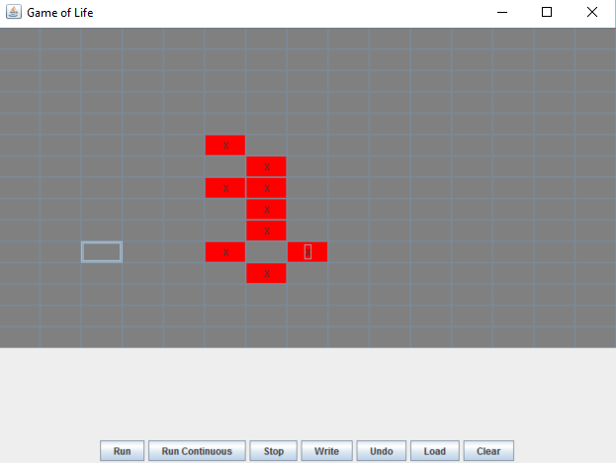

Click ‘Run Continuous’, and then wait for iterations to stop.

OUTPUT VALUES:

“Running…

Calculating…

Displaying…”

Repeating infinitely

POSTCONDITIONS: Conway’s Game of Life window looks like this after it has stopped visible iterations:

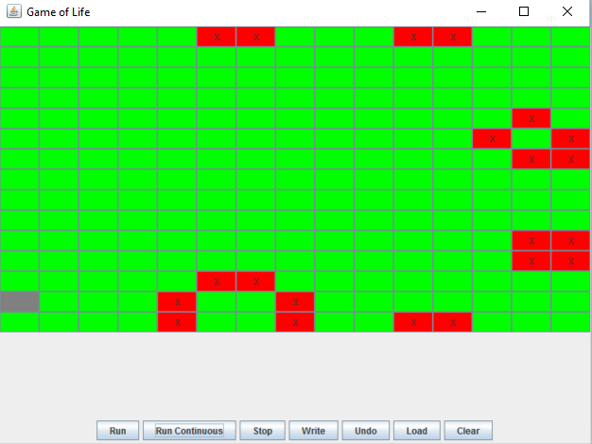

IDENTIFIER: INFINITELY LOOPING CONTINUOUS

TEST CASE: Check that a pattern that should loop infinitely on the Game of Life window will, in fact, infinitely loop.

PRECONDITIONS: Game of Life window is open and awaiting input from user

INPUT VALUES: Click on specific tiles in Game of Life window and then click Run Continuous

EXECUTION STEPS: Click specific tiles to result in following form:

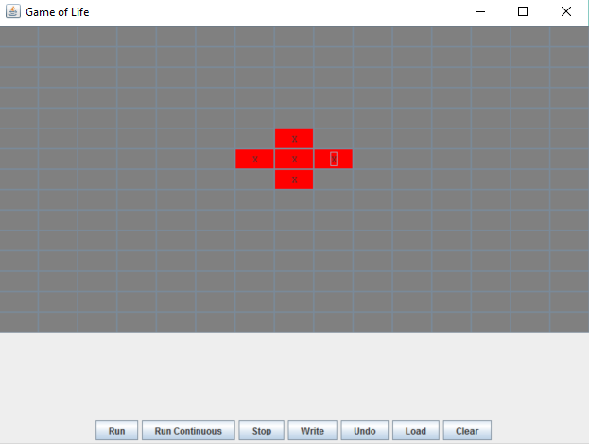

Click Run Continuous.

OUTPUT VALUES:

“Running…

Calculating…

Displaying…”

Repeating infinitely

POSTCONDITIONS:

Game of Life will be swapping quickly between these two configurations:

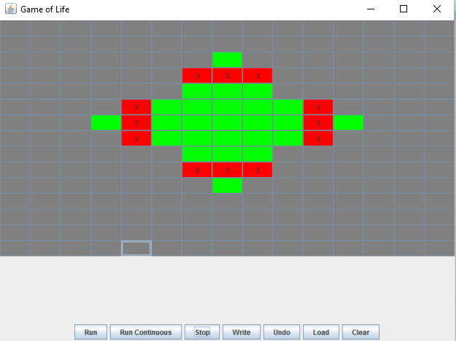

And

